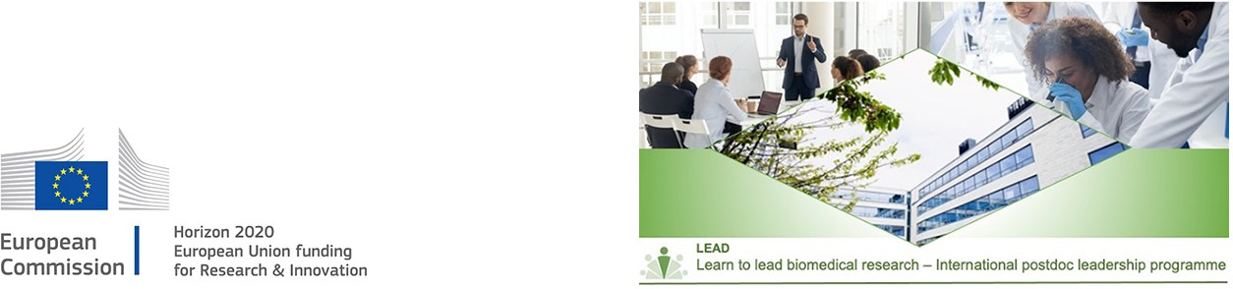

Mobility requirement

Declaration of eligibility

In order to be eligible for the Postdoc to research LEADer programme (LEAD), candidates must undertake transnational mobility according to the H2020 Marie S. Curie rules. This includes: All nationalities can apply, but you cannot have resided or carried out your main activity (such as work or study) in Denmark for more than 12 months in the 3 years prior to the call deadline. This excludes short stays such as holidays or compulsory national service. Also, candidates working at UCPH for more than 3 months before the deadline will be considered ineligible. Please fill the below declaration of place of activity/place of residence previous 3 years. Please indicate the period(s) and the country in which you have legally resided and/or had your main activity (work, studies, etc.) during the last 3 years – most recent first. Please fill in the table without gaps until the call deadline for LEAD.

Period from  (DD/MM/YYYY) | Period to  (DD/MM/YYYY) | Duration | Country | Activity

If applicable, please indicate the date of the entry in Denmark: DD/MM/YYYY or state N/A

Professional experience
Applicants must hold a PhD degree at the time of the application followed by up to 8 years of experience from for example academia, clinic, industry or biotech. Exceptions to these rules are made for applicants with prolonged career breaks due to parental leave, illness, or mandatory military/civil service (documentation should be uploaded in the application system).

PhD diploma obtained: DD/MM/YYYY

I hereby declare that I have read and agreed on all the rules and regulations regarding the eligibility criteria, and that all information mentioned in this form is correct.

Date and signature

