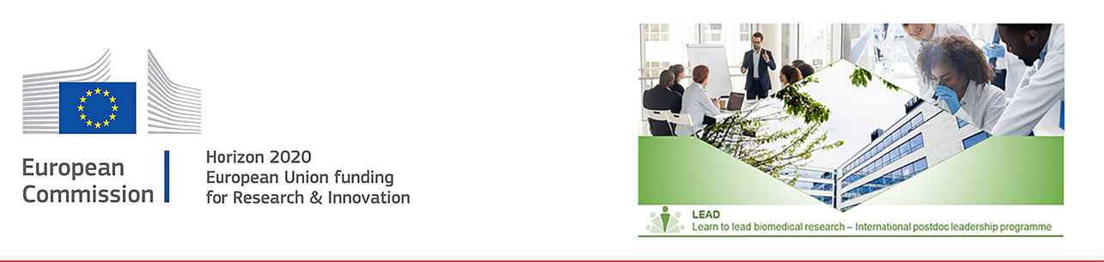

Research synopsis
The research synopsis should describe your vision for a scientific challenge you would like to pursue during the fellowship - it should NOT be a detailed project description. The scientific challenge should reflect both the expertise of you as the applicant and the host lab(s) you would like to join - clear transfer of knowledge is expected. Also, the synopsis should describe how your previous professional experience will ensure success in the training, and how the training in LEAD will help you reach the next step in your career (in or outside academia).

Please respect the following:
- a minimum font size of 11 points
- single line spacing
- margins (top, bottom, left, right) of 2cm (not including any footers or headers)
- a clearly readable font (e.g. Arial or Times New Roman)

Section A max 1 page

A- The research in a nutshell
Describe the broader context, the background for the topic/research area and the scientific challenge to be explored. Outline your vision including the hypothesis, the overall objective, and the potential research questions to be addressed. Describe the potential impact on the research field.

Section B, C, D combined max. 1 page

B- Originality and novelty aspects of the research
Explain the originality and innovative aspects of the research questions. Describe the potential interdisciplinary aspects and explain why the research is cutting-edge.

C- Research approach/methodology
Briefly outline the approach and overall research methodology. Why is it appropriate?

D- Transfer of knowledge and Impact on the host lab/institution
Outline your previously acquired knowledge and the research-related and transferable skills that you will transfer to the host lab and BRIC. Address the potential benefit the host lab and BRIC will gain from employing you.

Section E, F combined max. 1 page

E- Potential of the candidate
Demonstrate how your existing professional experience fit the outlined scientific challenge. Address how your actual research-related and transferable skills will help you to succeed with the training and research objectives.

F- Impact on your progression towards research independence
Outline the set of skills, both research-related and transferable, you will gain during the fellowship, both from the host lab as well as from the training in LEAD. Explain how these skills will help you reach the next step in your career (in or outside academia).

